***Source Code:***

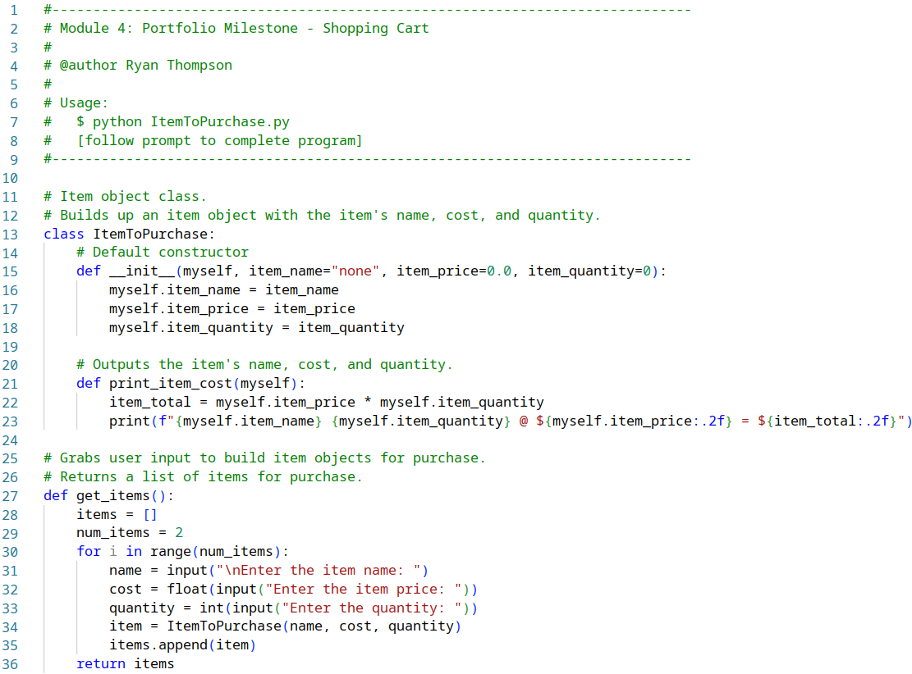

***Source Code Continued:***

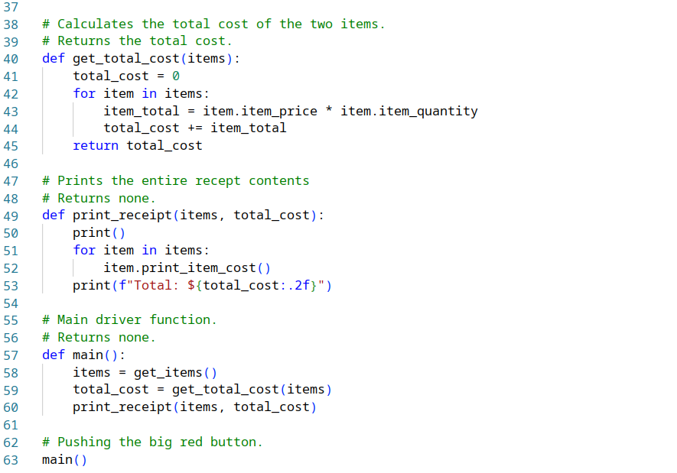

***Output:***

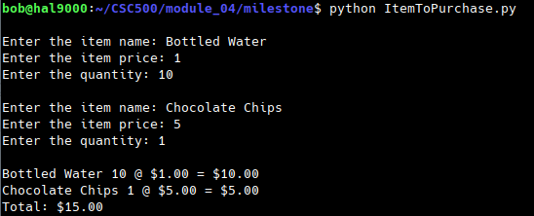

[***Github Repo***](https://github.com/rt75272/CSC500/tree/main/module_04/milestone)***:***

https://github.com/rt75272/CSC500/tree/main/module_04/milestone